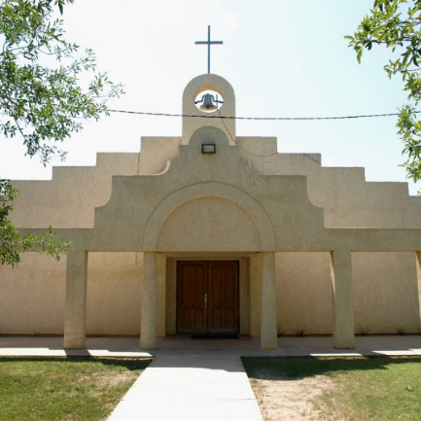
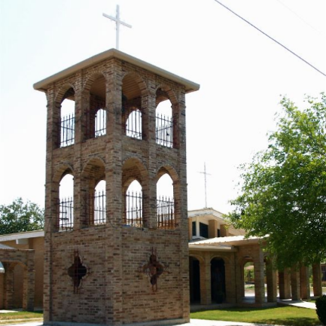
Saint Joseph (La Pryor)
&
St Patrick (Batesville)

Parish Purpose
Our Parish purpose is to help build and inspire our community to live with Faith, Love and Charity,
by sharing our compassion with others so that all can serve our Church and God.
Parish Vision
Our Parish vision is to
- build a stronger personal relationship with Jesus Christ.
- deepen our faith and prayer life.
- embrace His teachings as a guiding light in our lives and our community.
Our Parish Core Values
Faith
We realize our Catholic faith and tradition is to be lived in every aspect of our lives. Therefore, we will always strive to act in concert with the principles of our faith and love through the unity of people and our Church.
Behaviors:
- We will express love through Faith and unity of people.
- We will express love through the celebration of Mass.
- We will express love through the encouragement of prayer and worship, especially through popular devotion and the Mass.
Community
Community is expressed by mutual respect which builds a foundation that encourages unity for the Parish vision. We are people who invest in our Parish with love in everything God calls us to do.
Behaviors:
- This will have a lasting impact on family values which can be demonstrated by Parish involvement and commitment to serve God and our Parish.
Generosity
Generosity is love expressed as responding to the needs of our Parish by helping with our talents, treasure, and time.
Behaviors:
- Parishioners will volunteer in the various ministries especially serving young people, elderly, and those most in need.
- Parishioners will financially support the needs of our Church and community.

2023-2025 Parish Priorities

Engaging Youth and Young Adults - to form young people as missionary disciples of Jesus Christ.
Priority Leader(s): Maria Victorino
- By June 30, 2025, 50 teenagers experience the kerygma (initial proclamation of the Gospel) proclaimed through a weekend retreat.
  - Goal Leader(s): Lorenzo Martinez & Santos Diaz (Support Role)
- By December 31, 2025, increase by 10% the strongly agrees to “growing confidence in the Church’s teachings” among respondents under 18 to 25 in the Disciple Maker Index survey.
  - Goal Leader(s): Maria Luisa del Toro
Forming Ministry Leaders - to deepen their faith so they can be more effective in their pastoral work in the community.
Priority Leader(s): Grecia & Oscar
- By June 30, 2025, increase the respondents who attend a workshop about the Catholic faith (in person or online) quarterly or more frequently from 32% to at least 50% in the Disciple Maker Index survey.
  - Goal Leader(s): Adriana Mata
- By December 31, 2024, invite and train 25 new people to take active leadership roles in the Parish.
  - Goal Leader(s): Annette Bermea & Connie (Support Role)
Evangelizing and Re-evangelizing Families - to encourage families to grow and practice their Catholic faith.
Priority Leader(s): Carmen & Heather
- By December 31, 2024, involve 12 families in a monthly service that invites them to serve in the Mass and encourage prayer and devotion to Holy Family at home.
  - Goal Leader(s): Ronnie & Noe Campos
- By December 31, 2025, engage 10 families in bi-annual one-day family retreats reflecting on Advent and Lent.
  - Goal Leader(s): Cristina Sanchez & Ashley & Anne

